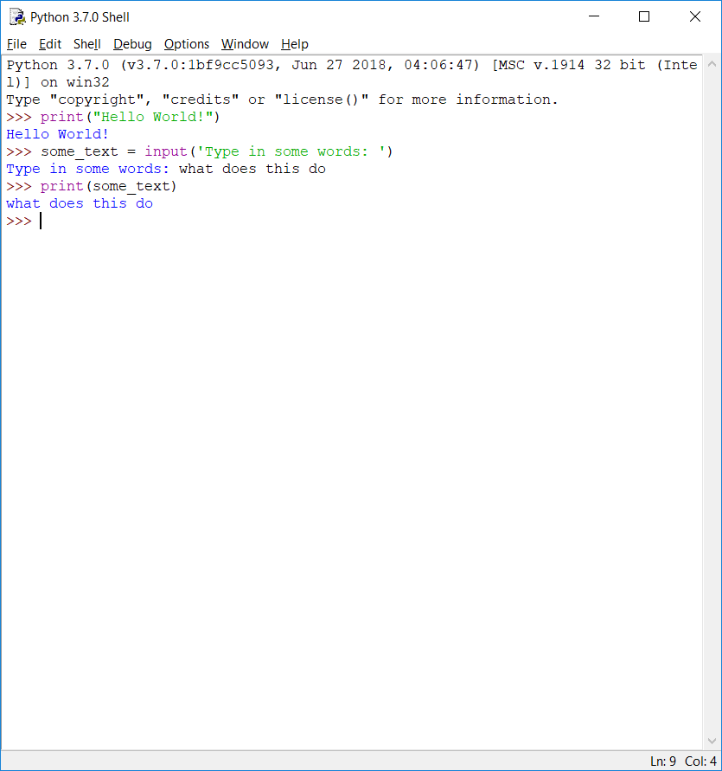

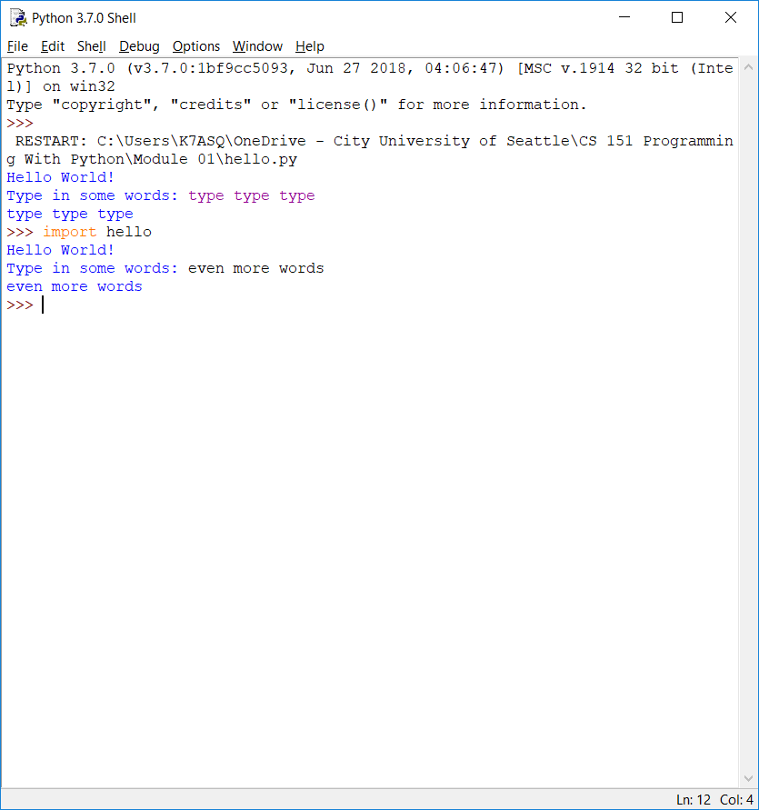

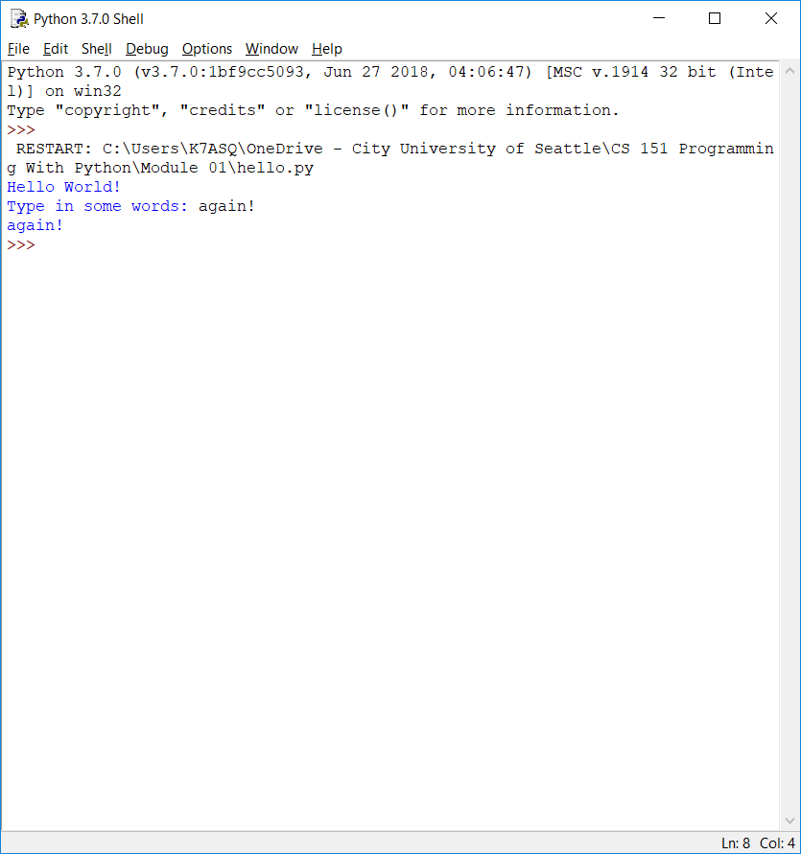

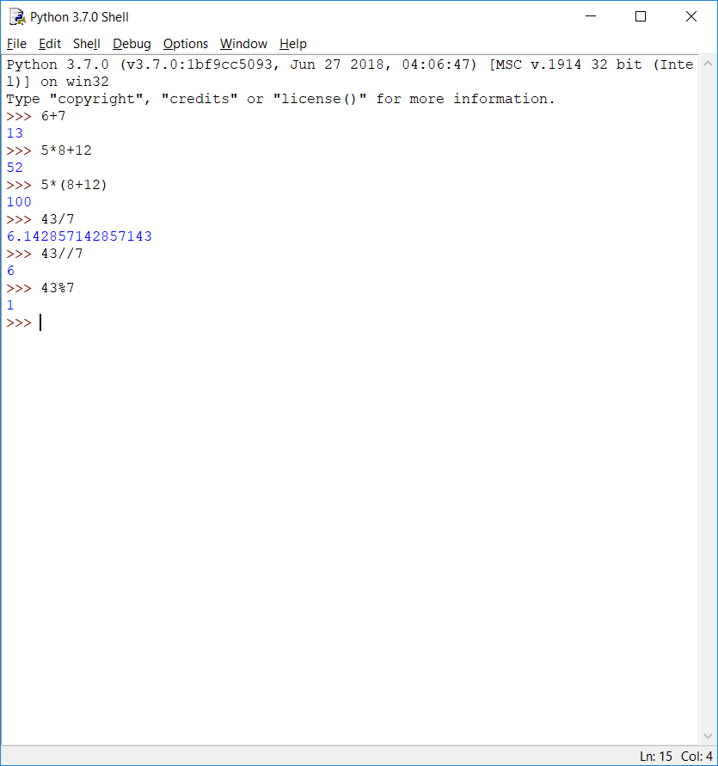

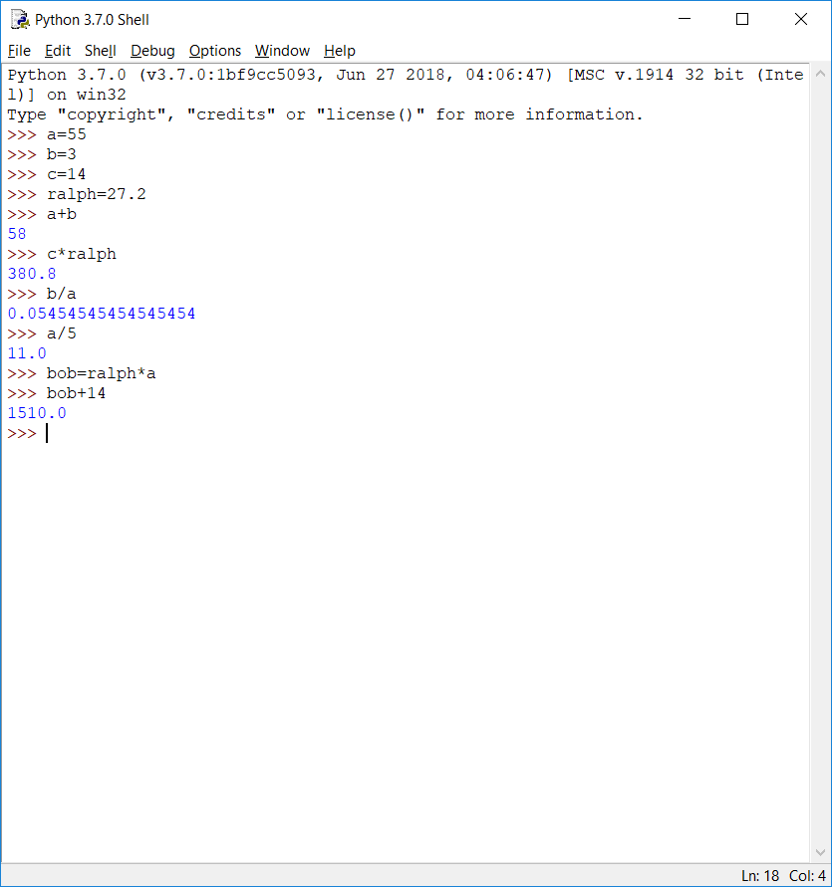

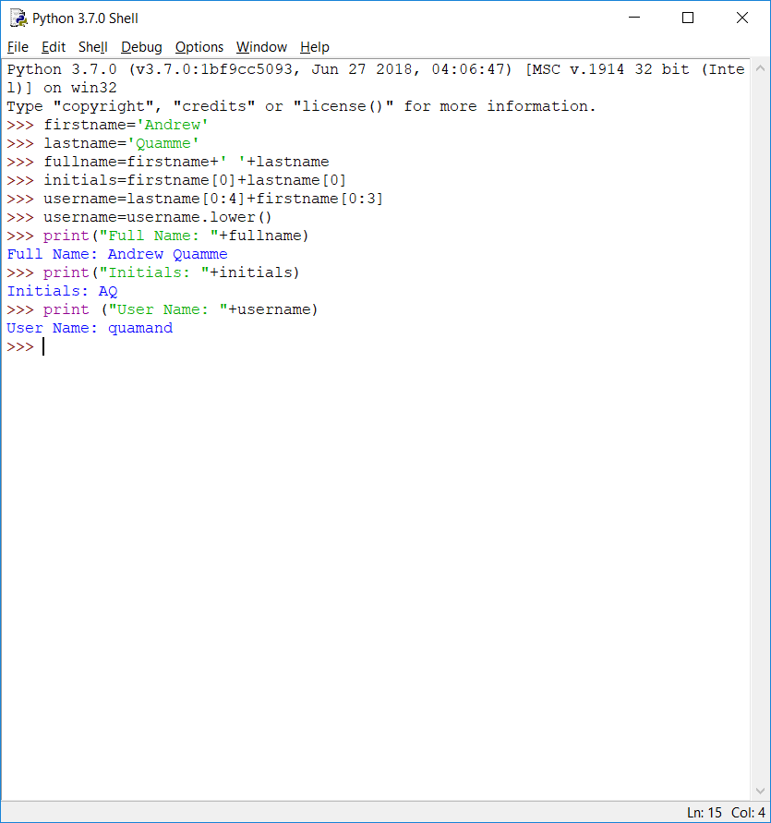

The syntax of Python so far seems similar to other languages I’ve used. The coloring and pop-up tips in the IDLE are also helpful for providing hints on how to do things I’m not familiar with. I did have some problems knowing when to use “ “ instead of ‘ ‘ and vice versa. I’m sure it will come with practice.